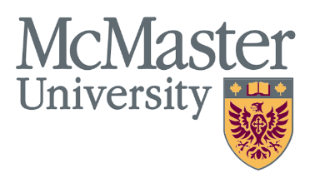

ONLINE EDUCATION FOR AUTO WORKERS!
The Unifor-McMaster University Labour Studies Program is designed specially for Unifor auto workers. As a Unifor member working for GM, Ford or FCA, you can take online education from the comfort of your own home, with fellow auto workers around the province, and work towards a university certificate. Why not try a course? No cost to our members, as fees are covered through a special funding arrangement with Unifor.
Unifor-McMaster Labour Studies Certificate
Winter 2022 Course Schedule
Is the economic system rigged against workers?  1 Session  A SHIFT | Professor Richard Wolff, of ‘Democracy @ Work’ joins us to discuss if the ways the economy may be rigged against working people in order to make big business rich. What are the alternatives for an economy that works for all?  Mon. Feb 7, 5:30-8:30 pm
The EV Shift: Challenges and opportunities for Canadian Auto  2 Sessions  A SHIFT | The shift to Electric Vehicle production is here. What might this mean for auto workers and the future of the industry? Angelo DiCaro, Director of Research at Unifor, joins us to discuss.  Mon. March 7 and 28th, 5:30-8:30pm
Do Canadian mining companies exploit workers overseas?  1 Session  B SHIFT | Canadian mining operations in Latin America and Africa have become notorious for exploiting workers and destroying the environment. A guest speaker from MiningWatch.ca will tell us what this is all about and what we can do about it.  Mon. March 21, 5:30-8:30pm
87 years since the ‘On to Ottawa Trek’: Are there lessons for today?  1 Session  B SHIFT | In 1935, during the great depression, thousands of unemployed Canadian workers rode railcars to Ottawa to demand jobs and workers rights. What was it all about and what lessons can we learn from it today? With McMaster Labour Studies Professor David Gouter.  Tues April 19, 5:30-8:30 pm
To register for a course, click here:

https://surveys.mcmaster.ca/limesurvey/index.php/879842?lang=en

For more info about our program, or to get on our email Bryce Thompson: bnwt94@gmail.com

Visit our website to at: https://labourstudies.mcmaster.ca/programs/unifor-certificate

To obtain the Certificate in Labour Studies from McMaster University, you must complete 36 course units. Most courses are worth 1 unit per night. We anticipate offering 4 unit courses in person at each local in the fall 2022, in addition to our online courses.

