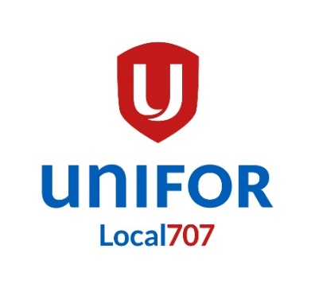

FORD CANADA

STRIKE BENEFITS BULLETIN

PLEASE READ CAREFULLY
IN ORDER THAT YOU WILL BE ABLE TO QUALIFY FOR STRIKE PAY

PICKET & STRIKE DUTY INSTRUCTIONS

Your union has set a strike deadline of 11:59 p.m. MONDAY SEPTEMBER 21, 2020. If no settlement is reached by the deadline, you are instructed to leave the plant peacefully and in good order. Please do not jump the gun as it interferes seriously with bargaining.

We will have 6 picketing locations that will be occupied 24 hours a day and 7 days a week until the strike is settled. Picket duties and locations will be assigned in 6-hour shifts, in time slots based on seniority. Due to COVID-19 restrictions, there will be no selection process for dates and times. You will be placed in a time slot based on seniority with the highest seniority members being assigned time slots starting at 6 AM to NOON until all shifts are filled. The shift you are assigned will be what you are required to picket for the duration of the strike. If the shift you are assigned does not work for you, it will be your responsibility to email 2020strike707@gmail.com or call 905-844-1791 and we will attempt to accommodate you if the reasons are valid. If you are unable to make it to your assigned picket duty it is your responsibility to contact your strike captain or the strike coordinator.
The list will be posted to the local website and will be in alphabetical order. Beside your name you will find your assigned picket location, time and day of week.

ELIGIBILITY FOR STRIKE PAY

You must participate in the strike activity assigned to you. This could be picket duty, kitchen duty, attendance at strike information classes, etc. You must be a member in good standing before the strike begins and register to participate.

STRIKE BENEFITS BULLETIN

STRIKE BENEFITS – AS PER UNIFOR CONSTITUTION

The Strike and Defence Fund shall pay benefits of $300.00 for each week of an authorized strike or lockout, prorated by day, including the first week, and additional medical, health or special assistance as provided for in the Strike and Defence Policy and criteria established by the National Executive Board.

HEALTH CARE

In the event of a strike, the National Union will maintain benefits as provided in your contract (except dental, hearing and vision care) such as drug, life insurance and accidental death and dismemberment premiums [not optional life insurance and A D & D for which the member pays the premium].

COVID-19

Due to the ongoing pandemic we will take all precautions to ensure the safety of our members and the public in the event of a strike. We ask that all members reporting for picket duty do so with a mask or face covering. IF you are experiencing any COVID like symptoms we ask that you do not report for strike duty and report your absence to your strike captain or the strike coordinator. Other measures will be in place for your safety and your strike captain will have more information when you arrive for your assigned strike duty. These protocols will need to be adhered to ensure the safety of all members picketing at your assigned location.

Strike Captains

If you are interested in being a STRIKE CAPTAIN, contact the Local via email 2020strike707@gmail.com or call 905-844-1791.

Brett Lefebre
Financial Secretary

Jan Smith
Strike Coordinator

/jr cope 343 Issued: September 9, 2020

